Intermediate Algebra Lecture 12.3: Graphing and Solving Exponential Functions

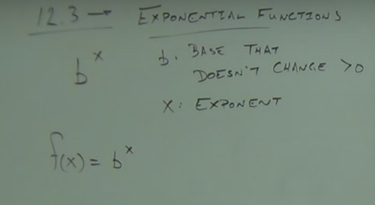

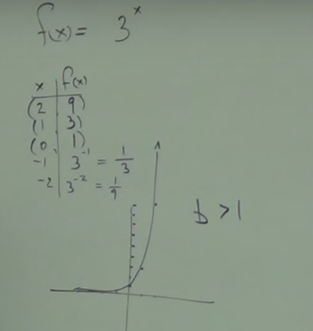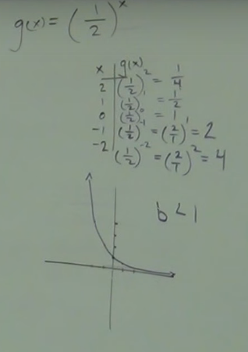

These graphs approach the x-axis but will never get there.

When base is greater than one (b>1) line will climb going to the right
When base is greater than one (b<1) line will climb going to the Left

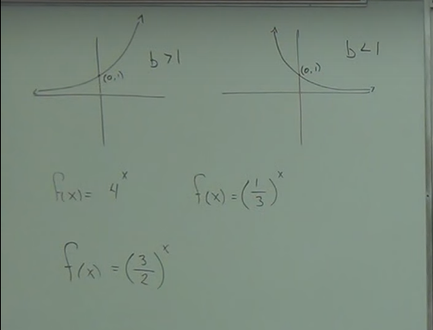

Solving
Idea: if bases are equal then the exponents must be equal
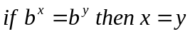

Goal, make the bases the same

Example
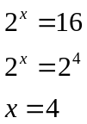

Example
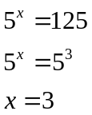

Example
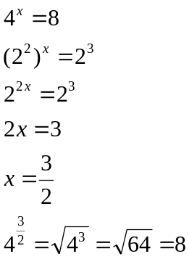

Example
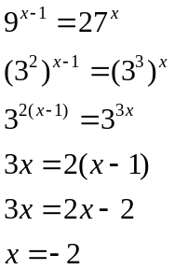

Example
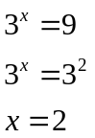

Example

Example
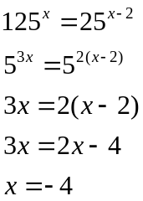

Example
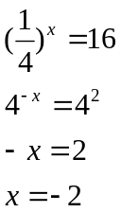

Interest:
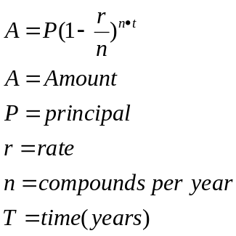

Find the amount owed at the end of 6 years
If 12,000 is loaned at a rate of 5% and compounded monthly ?

